PREVENTION OF FIRE IN ELECTRIC VEHICLES

R.Jyothirmai
Department of Information Technology
Vardhaman College of Engineering
Hyderabad-Telangana,501286, India
jyothirmairajremalli@gmail.com

R.Ajay Kumar
Department of Information Technology
Vardhaman College of Engineering
Hyderabad-Panatella,501286, India
ajayrachha1478@gmail.com
P.Varsha Sree
Department of Information Technology
Vardhaman College of Engineering
Hyderabad-Telangana,501286, India
varshasree2407@gmail.com

P.Vineesh Goud
Department of Information Technology Vardhaman College of Engineering
Hyderabad-Panatella,501286, India
vineeshgoud06@gmail.com
P.Deepak Teja
Department of Information Technology
Vardhaman College of Engineering
Hyderabad-Telangana,501286, India
deepakteja2004@mail.com
U.Shyam Sundhar
Department of Information Technology
Vardhaman College of Engineering
Hyderabad-Telangana,501286, India
shyansundhar647@gmail.com

A.Rajitha
Department of Information Technology
Vardhaman College of Engineering
Hyderabad-Panatella,501286, India
rajitha.it222@gmail.com

ABSTRACT

Electric cars, or EVs, have completely changed the global car industry because of the explosive advancements in lithium-ion batteries over the last ten years. However, the possibility of fires brought on by extremely potent batteries is a significant safety worry for EVs. The recent Electric fire safety problems, like heat runaway and battery life fires, are the main topic of this review. Thermal runaways, flames, explosions, and the release of poisonous fumes can result from extreme abuse, such as equipment failure or accidents. The paper presents an unbiased evaluation of the combustion risks associated with bus, hybrid, and electric batteries, emphasizing important test-derived fire characteristics. The Peak rate of heat release (PHHR) is influenced by the electrical ability of Li-ion batteries, suggesting that the fire risks associated with electric cars (EVs) are similar to those of cars powered by gasoline. Due to inherent battery ignition, EV fires are more difficult to put out and need a lot of suppression to cool down and stop them from starting again. In order to make EVs as safe as traditional cars, this project intends to support additional studies and developments to improve EV safety and foster collaboration between academics and industry.

Keywords: Electric Vehicles, Lithium Ion Battery, Coolant, Electric Vehicles Charging, Fire protection, EVs caught Fire, Battery Management System.

1.Introduction

An electric motor powers the electric vehicle (EV), which is driven by electricity. While most commonly applied to cars, the term "EV" can also more widely refer to rail automobiles, surface and underwater vessels as well as uses for aircraft.

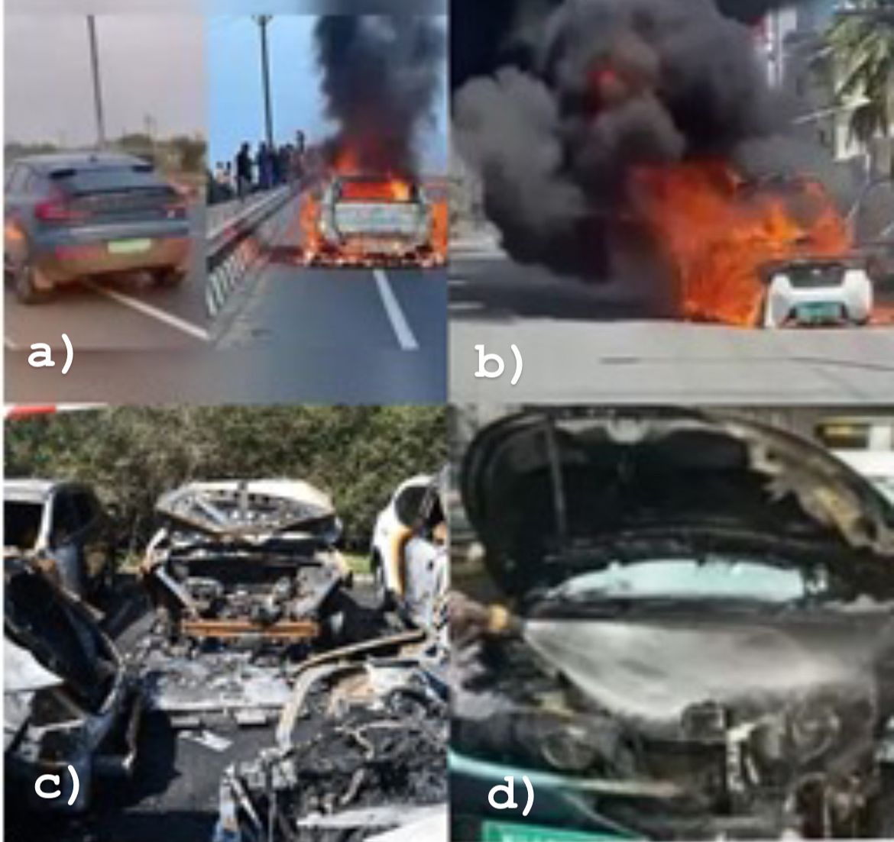
Figure-1 Fire accidents vehicles

(a) On January 29, 2024, a Volvo C40, which is Recharge electrical Vehicle caught fire on a Chhattisgarh highway . (b) In a incident at Bengaluru ,an electric car burst into flames on 1 oct 2023. (c) On Monday, September 12, 2023, a lithium battery in a car parked at the airport in Sydney caught fire, resulting in the destruction of five cars. (d) A Tata Nexon Electric Vehicle caught in pune city on 19 Apr 2023.
But from the 1930s, as petroleum and diesel became more reasonably priced and more accessible and allowed fueled by gasoline vehicles to travel farther and quicker, interest in EVs declined [3]. With billions of vehicle engines (ICEVs) in use today, 87% of petroleum, or roughly 33% of the world's energy, is used by these cars [4]. Global warming, finite natural energy supplies, and population growth all increase People's awareness of their own energy vulnerability and the need for greener modes of transportation. This assessment restricts the definition of "road EVs" to vehicles that are powered entirely or in part by lithium-ion cells (LIB). Battery electric automobiles (BEVs) solely run on electricity, while plug-in electric vehicle hybrids (PHEVs) and electric hybrid cars (HEVs) are additionally powered by gasoline or diesel engines. The electric car was created as a result of several developments in the fields of battery and electric motors. (EV) in the 1800s [1]. Because of shortages of fuel and environmental concerns, it was a brief time in the 1900s when EVs were in highly sold [2].

Electric Vehicles made a comeback to the worldwide scene at 21st era, coinciding with the LIB's explosive development during the 1990s. In addition to being a representation EVs today provide outstanding driving performance in the context of environmentally responsible transportation. However, EVs are still quite a ways from being mature when compared to gasoline-powered ICE which have been around for a century and have undergone constant development, particularly in terms of how safe they are thought to be in a fire. This safety issue prevents electric vehicles from taking the lead in transportation [5,6]. Similar to how gasoline or diesel are the main fuels for ICEV fires, the battery powers the EV and also serves as the primary fuel source for the EV fire. A overview of the dangers, hazards, and mechanisms behind battery thermal runaway has been published in [7–10]. These evaluations detailed current scientific understandings of cell fire dynamics and focused on the security features of cell substance &chemical science. Nevertheless, little is known about the general fire danger and EV hazards. Massive Electric cell pack and full-scale EV fire testing are costly & hardly reported. The market for electric vehicles is growing, and the number of EV owners is steadily rising. Despite unresolved fire safety concerns, LIB's energy density is still rising [11].

Consequently, there will be a higher chance of EV fire incidents. This essay examines these fire hazards in addition to EV mishaps those are powered by batteries, particularly LIBs. A thorough analysis is also conducted on the limited massive amounts fire tests conducted on EVs and the related fire-protection tactics.

2.Literature Review

One risk associated with cars is the possibility of fire occurrences. They have begun to be increasingly noticeable in EVs as their number rises. Most electric cars and PHEV fire incidents—especially those that involve self-ignition—are caused by problems using the battery electrical system. In terms of propulsion, the battery's capacity is comparable to that of a gasoline-powered vehicle's (ICEV) fuel tank. Consequently, EV fires are related to the design and capacity of the pack of batteries, as well as the risk and danger of fire associated with the cells in the battery and power system.
Generally speaking, the risk of fire for an electric vehicle increases with the quantity of batteries and their potential energy content [12]. EVs have the potential to use a very high number of batteries. This is required because a typical EV uses thousands of times more power than a typical smartphone, and it does it much faster. large power (up to 100 kW) and large capacity for energy (up to hundreds of kWh) are requirements for EV batteries. They satisfy major obstacles pertaining to weight and space constraints at the same time as keeping costs reasonable. EV batteries typically consist of a pack, modules, and cells. A battery module is made up of battery cells, which are the fundamental component of a LIB, coupled in series or parallel. The cells are fastened together and shielded from vibration, heat, and shocks from the outside world by a frame The battery pack is the assembly that holds the modules and pack infrastructure together. Power electronics, wiring, conditioning loops, and structural elements are all part of this infrastructure [13]. Moreover, a few of modules have temperature, charging/discharging, and power management systems incorporated [14].Usually, these are called Battery Management Systems (BMS). The EV has a sizable quantity of energy storage capacity because to its condensed assembly. However, this makes it more difficult to regulate the pack's heat [15].

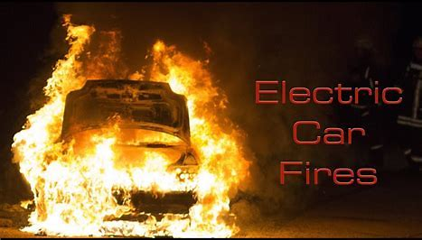
Figure-2 Fire in Electric Vehicles

Nonetheless, they fall within a number of categories:
The electric vehicle spontaneously or self-ignites when it is stationary. This may be related to extreme weather circumstances, such as extremes in humidity or temperatures. It may even bear some relevance to "spontaneous" internal cellular death. These problems are often linked to abuses that occurred within the LIB that exceeded its security threshold at a particular point in time.
The EV caught fire during charging.An EV's LIB gets harmed by a car accident or other types of abuse. Because of the extreme damage to the battery pack, the LIB burns during or just after the collision. The more EVs on the road, the greater the chance that one of these types of accidents will involve an EV. IV. After the original fire was extinguished, the LIB of the electric vehicle was exposed to heat abuse and rekindled. V. External factors, such as arson, forest fires, or an erupting structure nearby, is what ignites the LIB and EV.

Technical Overview

As of right now, there have been a lot of media conversations and extensive reporting on EV fire incidents. EV fires are still far less common than ICEV fires overall, despite this [16], this may be primarily because EVs' global market share is still far lower than that of ICEVs. According to statistics, arson is responsible for almost half allICE car fires, with flames that are already present starting many more[17].In an underground parking lot in Haarlem, Netherlands, without sprinklers, more than 26 cars were totaled in 2010.The massive chain reaction fire at a multi-story parking lot in Liverpool, UK in 2018 that caused damage to at least 1,400 cars may have been effectively extinguished by a sprinkler system.Put another way, a vehicle's flammability and fire safety are not the only factors that contribute to fire incidents. It is anticipated that EV fire incidents would resemble ICEV trends. Unfortunately, no exact figures are currently available regarding the distribution of the several causes of accidents involving electric vehicles, including arson, vehicle crashes, fires caused by other fires, and self-ignition. It should be mentioned that although ICEV self-igniting fire incidents occur frequently, older cars are typically involved in them. Most self-ignited fire accidents involving electric vehicles (EVs) and internal combustion engines (ICEVs) stem from their respective power architectures, the engine and batteries. Because most EVs are still relatively new and are becoming more and more commonplace worldwide, it is not scientifically feasible to evaluate the fire risk of ICEVs and EVs equally. The battery is usually identified as the primary source of an electric vehicle (EV) fire. However, there are numerous other potential causes for this, such as a malfunctioning charging system or an overburden of cables [18], setting other flammable objects on fire and arson. When electric vehicle fires do happen, they are usually complicated, recent events.

Implementation and optimization

Studies on battery thermal runaway and protection strategies are far more numerous than those on battery fire suppression and fire-extinguishing approaches. However, they have found that LIB fires are difficult to put out and might reignite, requiring a lot of suppressants [19]. Management of these rekindling flames presents a challenge since they might happen suddenly or even long after the initial thermal event. Make sure the car or LIB pack runs completely out of fuel to prevent reignition. Reignition risk decreases significantly when the LIB pack's active ingredient is all used up. In actuality, though, this might not always be feasible or the best course of action, in which case repression or extinguishment is required. Fires are divided into five classifications by NFPA 10-2018 [20]. Although an EV itself does not immediately fit under any of these groups, its constituent parts do. They can be split up like this: Solid combustible components in EVs, such as plastic interior décor and seat foam; Fluid fuels contained in hybrid electric vehicles, braking, windshield washer, gearbox, and coolant; C. D. Li metal pieces discharged from charged Li-ion batteries; E. electrical components and BMS Hazardous gases were removed from the battery after the thermal runaway. Therefore, if carbon monoxide or other chemicals are the only method of suppressing the battery fire, even though the fire can be confined, it cannot cool the battery pack or halt the re-ignition. On the other side, using water spray can put out the fire and cool the EV, but it may eventually lead to more electrical issues and interact with Li to produce hydrogen gas [21]. The majority of fire suppression tests carried out in the literature were restricted to portable, small-scale LIB flames, and the extinction process of LIB fires is poorly known, as detailed in. As a result, there is much disagreement over the reliability of current fire suppression methods and the effectiveness of control agents when it comes to EV fires[22]. Dry chemicals or carbon dioxide can put out a burning LIB's flames. But putting out a fire has to be weighed against the risk of combustible gas building up and an unforeseen ignition that could result in an explosion of gas [23]. It appears that keeping the LIB cold, or stopping heat from transferring between its cells, has mostly positive consequences. Water is a typical firefighting agent and has a significant cooling capacity, so even though it may have drawbacks like toxic runoff or short circuits, it's a smart option for controlling LIB fires[24]. Extensive testing of EV battery packs' fire suppression within a model vehicle: battery pack type A; battery pack type B with internal components; battery pack type A's fire behavior; and fire suppression measures [25].

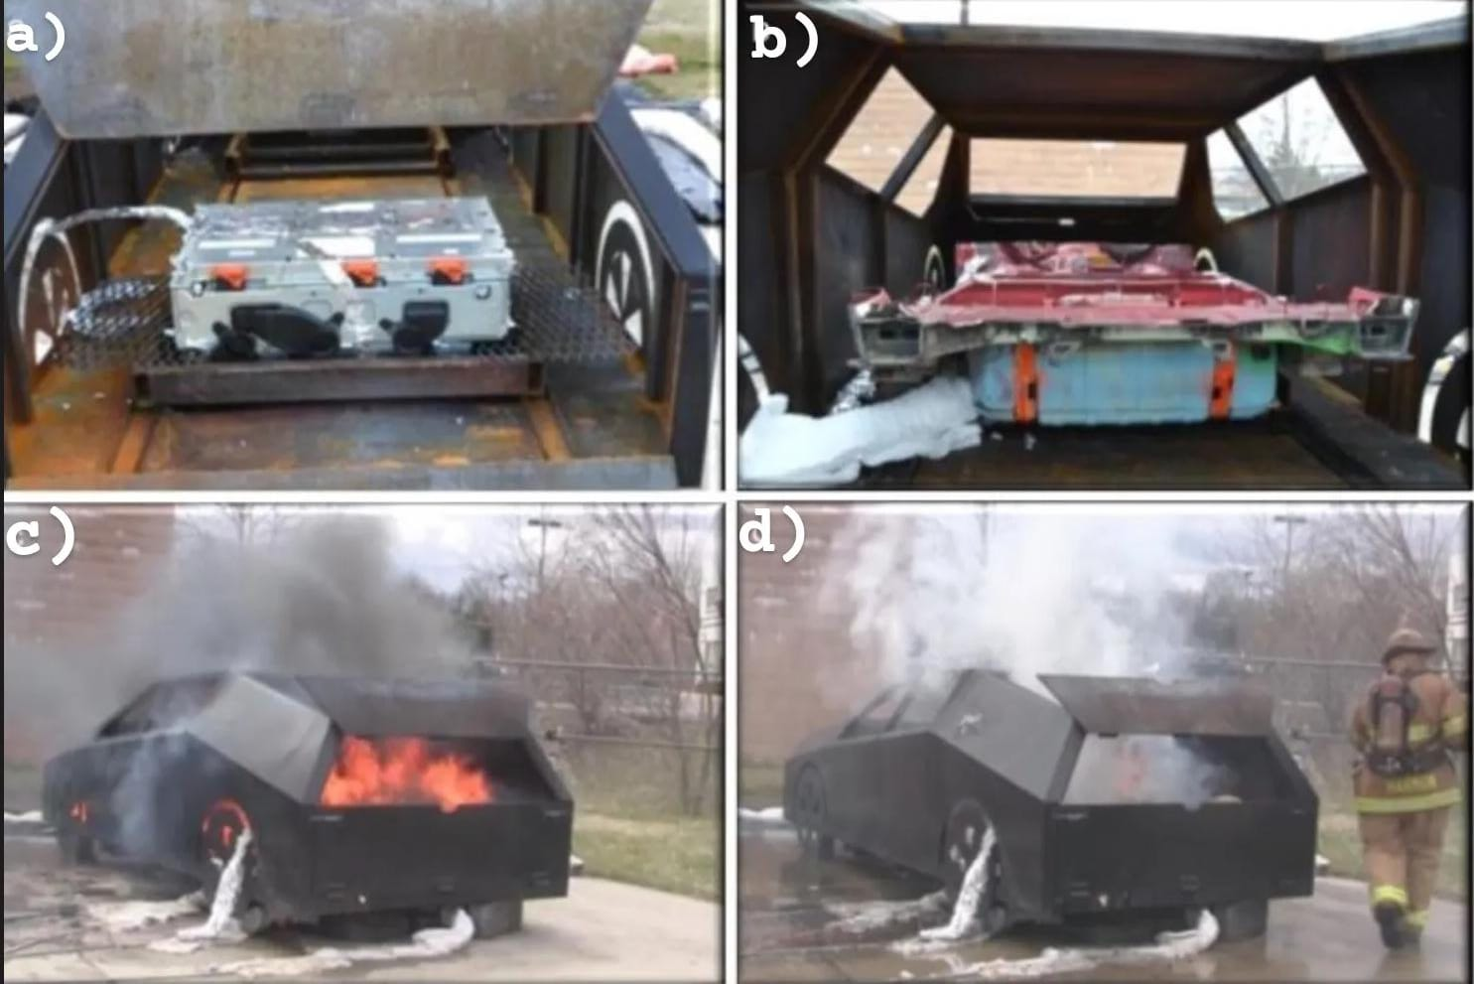
Figure-3 Coolants for Electric Vehicles
These days, a lot of heavy-duty ICEVs come equipped with a fire suppression system. These devices are put in place to safeguard the compartments that house auxiliary heaters and/or internal combustion engines. These are specifically frequently the main areas where a thermal incident or fire occurs. These kinds of systems can be turned on manually or automatically when they sense a fire[27]. The United Nations Economic and Regulation No. 107 states that [26], In 63 nations, using these technologies in buses is now mandated [28]. Coaches will be subject to this legislation beginning in 2021.Insurance authorities have established their own guidelines in SBF128 [29] and SBF127, correspondingly, for large vehicles and machines. These recommendations along with the test protocol SP Method 4912 [30], developed by RISE, have a connection. In a simulation of the combustion chamber of an engine, this standard looks at the system's performance in relation to hidden fires, class-A flames, high and low fire loads, ventilation, and reigniting fires [31].

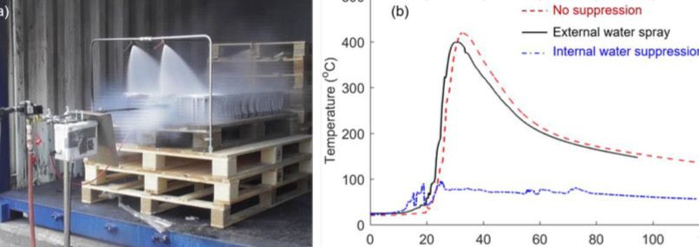
Figure-4 a)Suppression of Battery b)Graph

(a) A photo of the suppression test for EV battery fire, and (b) the temperature measurement of a battery near ignition location under different fire-suppression techniques.

Conclusion
This essay examines current cell fires in electric vehicles (EVs), along with the associated fire safety concerns and fire prevention techniques. Li-ion batteries (LIBs) pose a significant fire danger and hazard in electric vehicles (EVs) due to the high demands of vehicle performance and recharging speed, the likelihood of crashes, and the growing size and energy content of battery packs. A qualitative assessment of the dangers and risks of electric vehicle fire is provided by reviewing a number of common fire incidents including batteries EVs, hybridization EVs, and electric buses. Over the next few decades, as EVs continue to gain market share, it is anticipated that there will be a rise in EV fire incidents. Due to the extreme expense and trade secret restrictions, there have only been a very small number of large-scale EV fire experiments conducted thus far. However, current test results show that while EV fires may emit more harmful gases like HF through burning Li-ion batteries, their heat release rate is similar to that of fossil fuel- filled vehicle fires. The electrical capacity of the LIBs (𝐃𝐵 in W) affects the measured peak rate of heat release (PHHR in kW), crossing multiple scales as 𝑷𝑯𝑹𝑹 = 2𝑬𝑩 0.6. EV fires are more challenging to put out due to the potential for battery re-ignition and the difficulty of cooling the interior battery pack. Water is still seen to be the most efficient way to put out electric car fires, and a lot of water is required to cool and kill the battery. However, less suppressor is required if it is sprayed directly to the battery pack. Moreover, nothing is known about the fire risk connected to used battery packs and abandoned EVs. In the future, structures and parking lots housing a higher concentration of electric vehicles and charging stations have to be obliged to install better-designed fire safety systems. This study is to help researchers and industries work on batteries, EVs, and/or fire safety engineering in order to encourage active research collaborations and draw new studies on improving the general safety of future EVs. It won't be until then that EVs and conventional cars are as comfortable for society as they are.
Result
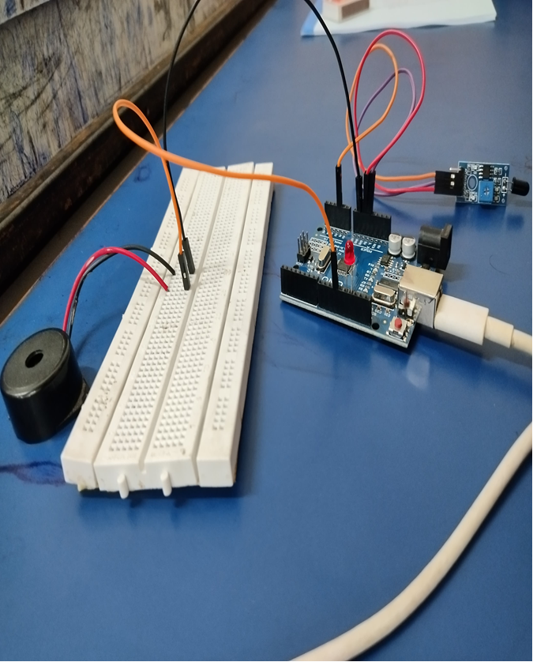
Figure-5 Prototype for the product(Prevention of fire in EVs)
Our prototype mainly works on the Smoke detecting sensor. This Smoke detecting sensor detects the temperature of Electric Vehicle then firstly, coolant tries to cool down the engine along with the buzzer sound.This process continues for 2 minutes after that the notification will be sent to the user through the app.

References

- Wang Q, Ping P, Chen C, Sun J, Chu G, Zhao X, and Sun J. Lithium-ion battery fire and explosion were triggered by thermal runaway. Power Sources Journal 2012; 208:210–24.10.1016/j.jpowsour.2012.02.038 is the doi.
- Sun J, Wang Q, Mao B, and Stoliarov SI. an overview of fire safety measures and lithium-ion battery failure processes. 2019; 73:95–131; Progress in Energy and Combustion Science.10.1016/j.pecs.2019.03.002 is the doi.
- Ouyang M, Xia Y, He X, Liu X, Lu L, and Feng X. Review of the lithium-ion battery's thermal runaway mechanism for electric cars. Materials for Energy Storage, 2018; 10:246–67. 1016/j.ensm.2017.05.013, doi:10.
- Ouyang D, Wang Z, Weng J, Chen M, Huang Q, and Wang J. A review of the lithium-ion battery's thermal risks and the appropriate precautions. Science Applied 2019; 9:2483. doi:10.122483-app-10-3390.
- Evarts Electrical Co. Lithium batteries: Up to its maximum potential. doi:10.1038/526S93a. Nature 2015; 526: S93–5.
- Lopes JAP, Garcia-Valle R (2006). Integration of electric vehicles with contemporary power networks. 2013. New York: Springer-Verlag; doi:10.1007/978-1-4614-0134-6
- Dimitrios Rizoulis; Andreas Dinger; Ripley Martin; Xavier Mosquet; Maximilian Rabl; Russo, Massimo S. Electric car batteries: prospects, challenges, and outlook through 2020. Boston Consulting Group, 2010.
- Ozdogan, M., and T. W. Sammis (2001). A GIS-based and remote sensing model to evaluate the Upper Missouri River Basin's regional evapotranspiration. Hydrology Journal, 251(1-4), 219–229.
- Mahmoud, M., Jaber, H., Tan, Y.C., Obaideen, K., Yousef, B.A., AlMallahi, M.N., and Ramadan, M., 2022. A summary of IoT-based smart irrigation systems. p. 100124 in Energy Nexus, 7.
- 10. Khalil Najafi, Brian Stark, and Timothy J. HarpsterSensors and Actuators: A passive wirelessly integrated humidity sensor A: Tangible,From https://www.sciencedirect.com/science/article/pii/S0924424701007208, one can access the publication 10.1016/S0924-4247(01)007208.
- Low- Power Broad Area Networks: An Overview, Raza, U., Kulkarni, P., and Sooriyabandara, M. IEEE Communication Society Survey Supplement 2017, 19, 855–873.
- Pule, M., Chuma, J., and Yahya, A. Wireless Sensor Network: An investigation into water quality monitoring. 2017; J. App. Res. Technol. 15, 562–570.
- In the IEEE Internet of Things Journal, volume 6, issue 1, pages 997–1009, February 2019, H. Guo, H. Huang, Y. -E. Sun, Y. Zhang, S. Chen, and L. Huang, "Chaac: Real-Time and Fine-Grained Rain Detection and Measurement Using Smartphones," published online. doi: 10.1109/JIOT.2018.2866690.
- Chane, H., Kadam, D., and Kothari, S. (2015). Using sensors, cloud computing, mobile computing, big data analysis, and the internet of things (IoT), a multidisciplinary paradigm for smart agriculture is presented. 374–382, International Journal of Computer Technology & Applications, 6(3).
- Clemens, C., Radschun, M., Himmel, J., & Kanoun, O. (2024). Jobst, A. E. Raindrop detection and precipitation calculation using signal processing and calibration of an inexpensive inductive rain sensor. 227 Measurement, 114286.
- Kamelia, L., Faroqi, A., Ramdhani, M.A., and Rifadiapriyana, V., January 2018. installation of an automated watering and humidity monitoring system. In Materials Science and Engineering, IOP Conference Series (Vol. 288, p. 012022). IOP Books
- Mehetre, D., Chikankar, P.B., and Das, S. (2015), Jan. automated irrigation system using a wireless sensor network utilizing ZigBee technology. The Fourth International Conference on widespread computing (ICPC), 2015, pp. 1–5. IEEE.
- Zounis, A., Bartzanas, T., Katsoulas, N., and Kittas, C. Agriculture with the Internet of Things: current developments and upcoming obstacles. 2017; Biosyst. Eng. 164, 31–48.
- Sangavi, T., Mohan, S., Soundharya, A., Darshna, S., & Desikan, S. (2015). clever irrigation setup. 10(3), 32–36, IOSR Journal of Communication and Electronics Engineering (IOSR-JECE).
- Sharma, D. K., Singh, R., and Jagdish, M. (2018). Using rain and soil moisture sensors, a low-cost autonomous watering system is designed and developed. 8(5), 1183-1187, the international issue of Current Technology and Engineering.(IRJET-V5I3412.pdf, available at https://www.irjet.net/archives/V5/i3/.
- Wang Q, Ping P, Chen C, Sun J, Chu G, Zhao X, and Sun J. Lithium-ion battery fire and explosion were triggered by thermal runaway. Power Sources Journal 2012; 208:210–24.10.1016/j.jpowsour.2012.02.038 is the doi.
- Erdarts EC. Lithium batteries: Lithium to its maximum potential. doi:10.1038/526S93a. Nature 2015; 526: S93–5.
Lopes JAP, Garcia-Valle R
- Integration of electric vehicles with contemporary power networks. 2013. New York: Springer-Verlag; doi:10.1007/978-1-4614-0134-6
- Dimitrios Rizoulis; Andreas Diger; Ripley Martin; Xavier Mosquet; Maximilian Rabl; Russo, Massimo S. Electric car batteries: prospects, challenges, and outlook through 2020. Boston Consulting Group, 2010.
- 25. Dames C, Park S, Moura S, Li J, Hao M. Li-ion battery thermal management more efficient using a shape memory alloy-based passive interfacial thermal regulator. 2018, 3:899–906; doi:10.1038/s41560-018-0243-8. Nature Energy.
- Present GJ. automated cars and transportation electrification. doi:10.1039/C4EE02229G. Energy & Environmental Science. 2015; 8:26–30.
- Frost & Sullivan. 2018 Global Market Outlook for Electric Vehicles.
- Long S. and Egbue O. An examination of customer attitudes and beliefs regarding the obstacles to the mainstream adoption of electric vehicles. 48:717–729 in Energy Policy (2012); doi: 10.1016/j.enpol.2012.06.009.
- International Agency for Energy. Cross-modal electrification is the direction of the 2018 Global EV Outlook. doi:10.1787/9789264302365-en, IEA Publications, 2018.
- Study of high-energy lithium-ion battery fire behavior and full-scale burning test by Ping P, Sun JH, Kong DP, Huang PF, Wang QS, Li K, et al.Journal of Power Sources, 2015;285:80–9. doi:10.1016/j.jpowsour.2015.03.035.
- Fire Tests of Electrical Vehicle Battery Cells and Packs, 2015;16:15964;doi:10.1080/15389588.2015; Sturk D, Hoffmann L, Ahlberg Tidblad A.

